CREATE DATABASE SoftwareHouse; USE SoftwareHouse;

SET SQL_SAFE_UPDATES = 0;

# # % Table Creation %

**CREATE TABLE Client (**

|  |  |  |
| --- | --- | --- |
| ClientID | INT | NOT NULL , |
| FirstName | VARCHAR(255) | NOT NULL, |
| LastName | VARCHAR(255) | NOT NULL, |
| Email | VARCHAR(255) | NOT NULL, |
| Phone | VARCHAR(255) | NOT NULL, |
| Address | VARCHAR(255) | NOT NULL, |
| PRIMARY KEY (ClientID) |  |  |

# );

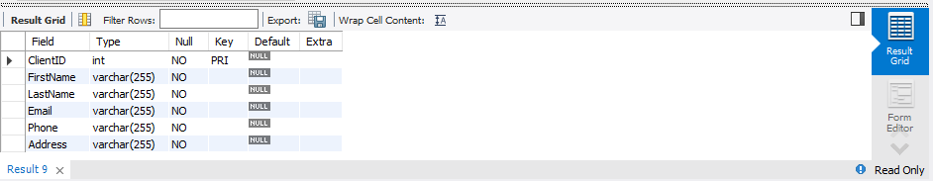

**CREATE TABLE Employee (**

|  |  |  |
| --- | --- | --- |
| EmployeeID | INT | NOT NULL , |
| FirstName | VARCHAR(255) | NOT NULL, |
| LastName | VARCHAR(255) | NOT NULL, |
| Email | VARCHAR(255) | NOT NULL, |
| Phone | VARCHAR(255) | NOT NULL, |
| Address | VARCHAR(255) | NOT NULL, |
| HireDate | DATE | NOT NULL, |
| Salary | INT | NOT NULL, |
| PRIMARY KEY (EmployeeID) |  |  |

# );

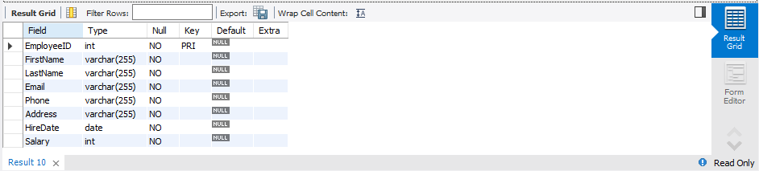

**CREATE TABLE Project (**

|  |  |  |
| --- | --- | --- |
| ProjectID  Title | INT  VARCHAR(255) | NOT NULL ,  NOT NULL, |
| Description | VARCHAR(255) | NOT NULL, |
| StartDate | DATE | NOT NULL, |
| EndDate | DATE | NOT NULL, |
| PRIMARY KEY (ProjectID) |  |  |

# );

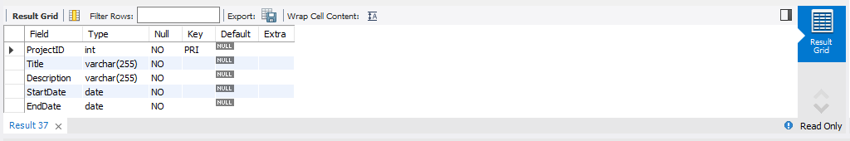

**CREATE TABLE Task (**

|  |  |  |
| --- | --- | --- |
| TaskID | INT | NOT NULL , |
| Description | VARCHAR(255) | NOT NULL, |
| StartDate | DATE | NOT NULL, |
| EndDate | DATE | NOT NULL, |
| PRIMARY KEY (TaskID) |  |  |

# );

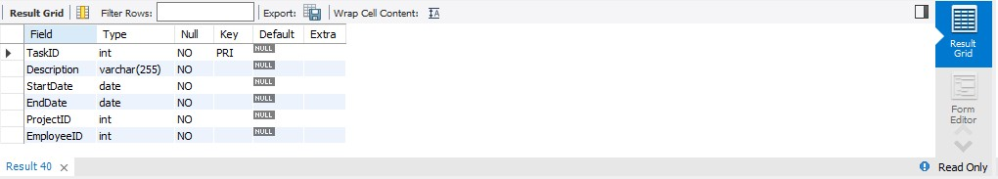

**CREATE TABLE Service (**

|  |  |  |
| --- | --- | --- |
| ServiceID  Name | INT  VARCHAR(255) | NOT NULL,  NOT NULL, |
| Description | VARCHAR(255) | NOT NULL, |
| PRIMARY KEY (ServiceID) |  |  |

# );

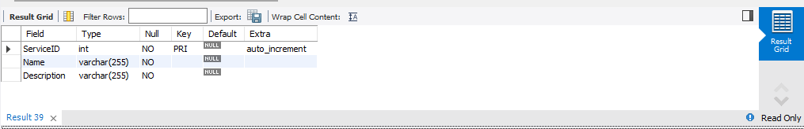

**CREATE TABLE Contract (**

|  |  |  |
| --- | --- | --- |
| ContractID StartDate  EndDate | INT DATE  DATE | NOT NULL , NOT NULL,  NOT NULL, |
| TermsAndConditions | VARCHAR(255) | NOT NULL, |
| PRIMARY KEY (ContractID) |  |  |

# );

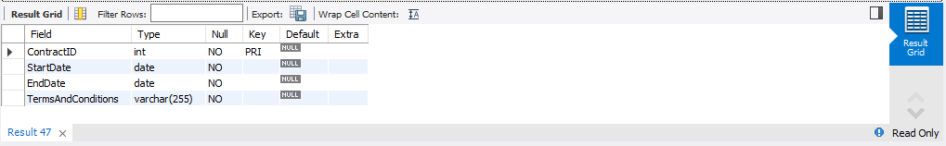

**CREATE TABLE Payment (**

|  |  |  |
| --- | --- | --- |
| PaymentID | INT | NOT NULL , |
| Amount | INT | NOT NULL, |
| PaymentDate | DATE | NOT NULL, |
| PRIMARY KEY (PaymentID) |  |  |

# );

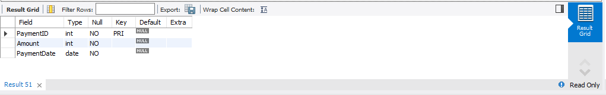

**# % Adding Foreign Keys %**

# ALTER TABLE Project

ADD ClientID INT,

ADD FOREIGN KEY (ClientID)

REFERENCES Client (ClientID) ON DELETE CASCADE

ON UPDATE CASCADE;

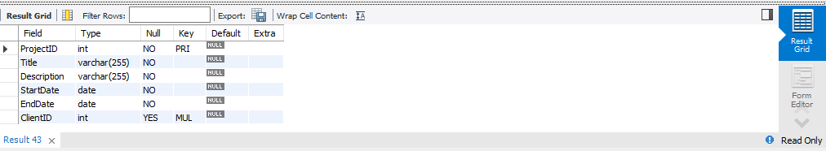

# ALTER TABLE Task

ADD ProjectID INT,

ADD FOREIGN KEY (ProjectID)

REFERENCES Project (ProjectID) ON DELETE CASCADE

ON UPDATE CASCADE;

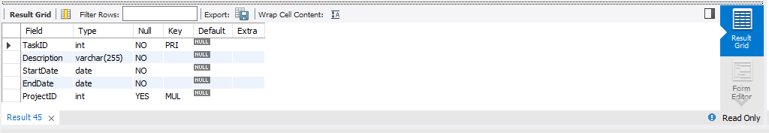

# ALTER TABLE Task

ADD EmployeeID INT,

ADD FOREIGN KEY (EmployeeID)

REFERENCES Employee (EmployeeID) ON DELETE CASCADE

ON UPDATE CASCADE;

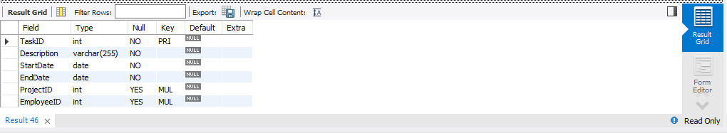

# ALTER TABLE Contract

ADD ServiceID INT,

ADD FOREIGN KEY (ServiceID)

REFERENCES Service (ServiceID) ON DELETE CASCADE

ON UPDATE CASCADE;

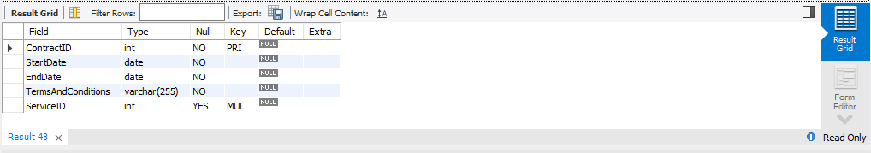

# ALTER TABLE Contract

ADD ClientID INT

ADD FOREIGN KEY (ClientID)

REFERENCES Client (ClientID) ON DELETE CASCADE

ON UPDATE CASCADE;

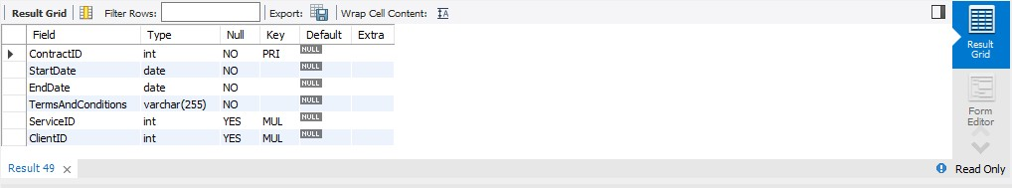

# ALTER TABLE Contract

ADD EmployeeID INT

ADD FOREIGN KEY (EmployeeID)

REFERENCES Employee (EmployeeID) ON DELETE CASCADE

ON UPDATE CASCADE;

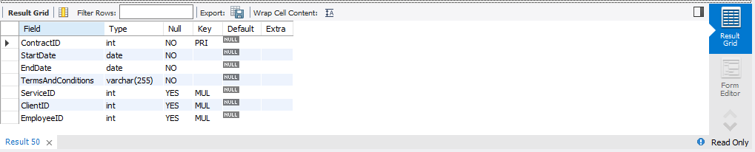

# ALTER TABLE Payment

ADD ContractID INT,

ADD FOREIGN KEY (ContractID)

REFERENCES Contract (ContractID) ON DELETE CASCADE

ON UPDATE CASCADE;

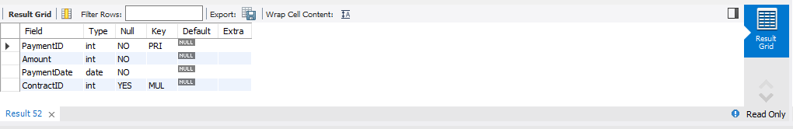

# # % Inserting Data %

**INSERT INTO Client (ClientID, FirstName, LastName, Email, Phone, Address) VALUES**

(1, 'John', 'Doe', 'johndoe@gmail.com', '123-456-7890', '123 Main Street'),

(2, 'Jane', 'Smith', 'janesmith@gmail.com', '555-667-8901', '456 Elm Street'),

(3, 'Michael', 'Jones', 'michaeljones@gmail.com', '789-012-3456', '789 Oak Street'),

(4, 'Sarah', 'Williams', 'sarahwilliams@gmail.com', '901-234-5678', '101 Maple Street'),

(5, 'David', 'Brown', 'davidbrown@gmail.com', '234-567-8901', '234 Pine Street'),

(6, 'Emily', 'Green', 'emilygreen@gmail.com', '567-890-1234', '345 Elm Street'),

(7, 'Peter', 'White', 'peterwhite@gmail.com', '890-123-4567', '456 Oak Street'),

(8, 'Susan', 'Black', 'susanblack@gmail.com', '012-345-6789', '567 Maple Street'),

(9, 'Thomas', 'Gray', 'thomasgray@gmail.com', '345-678-9012', '789 Oak Street'),

(10, 'Nancy', 'Pink', 'nancypink@gmail.com', '678-901-2345', '101 Maple Street');

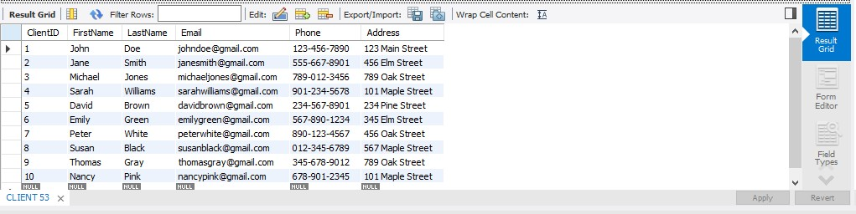

# INSERT INTO Employee (EmployeeID, FirstName, LastName, Email, Phone, Address, HireDate, Salary)

**VALUES**

(1, "John", "Doe", "[johndoe@example.com](mailto:johndoe@example.com)", "555-555-1212", "21 Oslo St", "2022-02-01",

52000),

(2, "Jane", "Doe", "[janedoe@example.com](mailto:janedoe@example.com)", "555-555-1212", "23 Greenfield Rd",

"2021-04-01", 55000),

(3, "Bob", "Smith", "[bobsmith@example.com](mailto:bobsmith@example.com)", "555-555-1212", "143 Main St",

"2009-01-01", 80000),

(4, "Sue", "Johnson", "[suejohnson@example.com](mailto:suejohnson@example.com)", "555-555-1212", "113 Main Rd",

"2021-11-01", 60000),

(5, "Mike", "Brown", "[mikebrown@example.com](mailto:mikebrown@example.com)", "555-555-1212", "21 Main Victoria Rd",

"2007-11-01", 90000),

(6, "Mary", "Jones", "[maryjones@example.com](mailto:maryjones@example.com)", "555-555-1212", "87 Victoria St",

"2018-10-01", 10000),

(7, "Tom", "Wilson", "[tomwilson@example.com](mailto:tomwilson@example.com)", "555-555-1212", "122 Main Rd",

"2023-08-01", 30000),

(8, "Lisa", "Davis", "[lisadavis@example.com](mailto:lisadavis@example.com)","555-555-1212","123 Victoria Road","2021/03/01 ","40000"),

(9,"Bill","Miller","[billmiller@example.com](mailto:billmiller@example.com)","555.555.1212","139 Main St","2012/08/01","50000"),

(10,"Karen","Taylor","[karentaylor@example.com](mailto:karentaylor@example.com)","555.555.1212","256 Victoria St","2020/05/01","20000");

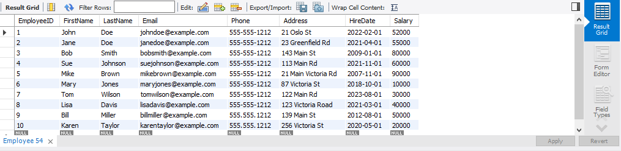

# INSERT INTO Project (ProjectID, Title, Description, StartDate, EndDate, ClientID) VALUES

(1, 'Inventory Manager', 'Develop a new software application to manage inventory.', '2023-01-01', '2023-03-01', 1),

(2, 'Website Developement', 'Design and build a new website to promote products and services.', '2023-02-01', '2023-04-01', 2),

(3, 'Marketing Compaign', 'Implement a new marketing campaign using print, online, and social media.', '2023-03-01', '2023-05-01', 3),

(4, 'Market Research', 'Conduct market research to understand target market and needs.', '2023-04-01', '2023-06-01', 4),

(5, 'White Paper', 'Write a white paper to educate customers about new technology.', '2023-05-01', '2023-07-01', 5),

(6, 'Training Program', 'Create a new training program to train employees on new software application.', '2023-06-01', '2023-08-01', 6),

(7, 'Product', 'Develop a new product to solve a specific problem.', '2023-07-01', '2023-09-01', 7),

(8, 'Customer Support', 'Provide customer support via phone, email, and chat.', '2023-08-01', '2023-10-01', 8),

(9, 'Management', 'Manage a project to develop new software application.', '2023-09-01', '2023-11-01', 9),

(10, 'Website', 'Deliver a project on time and within budget to develop new website.', '2023-10-01', '2023-12-01', 10);

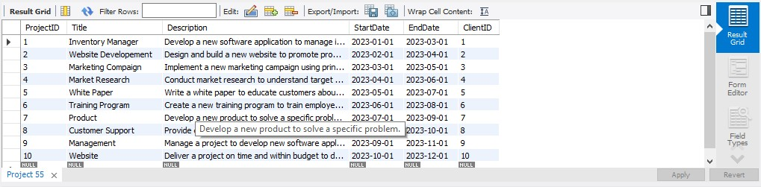

# INSERT INTO Task (TaskID, Description, StartDate, EndDate, ProjectID, EmployeeID) VALUES

(1, 'Develop the user interface.', '2023-01-01', '2023-03-01', 1, 1),

(2, 'Develop the database.', '2023-02-01', '2023-04-01', 1, 2),

(3, 'Implement the user stories.', '2023-03-01', '2023-05-01', 1, 3),

(4, 'Write the unit tests.', '2023-04-01', '2023-06-01', 1, 4),

(5, 'Integrate the modules.', '2023-05-01', '2023-07-01', 1, 5),

(6, 'Deploy the application.', '2023-06-01', '2023-08-01', 1, 6),

(7, 'Test the application.', '2023-07-01', '2023-09-01', 1, 7),

(8, 'Fix bugs.', '2023-08-01', '2023-10-01', 1, 8),

(9, 'Release the application.', '2023-09-01', '2023-11-01', 1, 9),

(10, 'Provide support to users.', '2023-10-01', '2023-12-01', 1, 10);

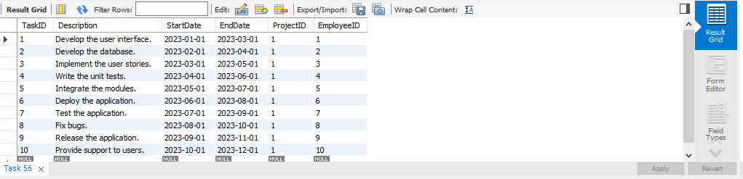

# INSERT INTO Service (ServiceID, Name, Description) VALUES

(1, 'Software Development', 'We develop custom software applications to meet your business needs.'),

(2, 'Website Design and Development', 'We design and develop beautiful and functional websites that will help you grow your business.'),

(3, 'Marketing', 'We help you reach your target audience with effective marketing campaigns.'), (4, 'Consulting', 'We provide expert advice and guidance on a variety of business-related topics.'),

(5, 'Training', 'We offer a variety of training programs to help you and your employees develop the skills you need to succeed.'),

(6, 'Support', 'We provide 24/7 support to ensure that your software applications and websites are always up and running.'),

(7, 'Security', 'We help you protect your data from unauthorized access.'),

(8, 'Cloud Computing', 'We help you move your business to the cloud so you can save money and improve efficiency.'),

(9, 'Data Analytics', 'We help you make sense of your data so you can make better business decisions.'),

(10, 'Mobile App Development', 'We develop mobile apps that will help you reach your target audience on their mobile devices.');

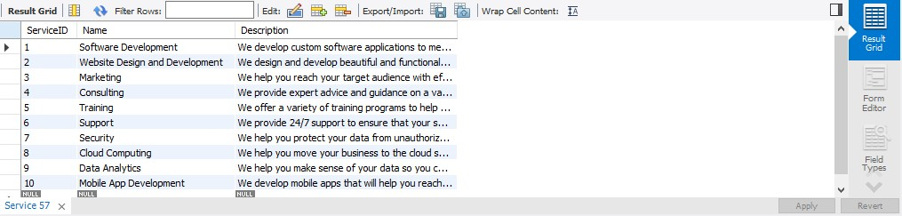

# INSERT INTO Contract (ContractID, ServiceID, ClientID, EmployeeID, StartDate, EndDate, TermsAndConditions)

**VALUES**

(1, 1, 1, 1, '2023-01-01', '2023-03-01', 'This is the contract terms and conditions for Inventory Manager Project.'),

(2, 2, 2, 2, '2023-02-01', '2023-04-01', 'This is the contract terms and conditions for Website Developement.'),

(3, 3, 3, 3, '2023-03-01', '2023-05-01', 'This is the contract terms and conditions for Marketing Compaign.'),

(4, 4, 4, 4, '2023-04-01', '2023-06-01', 'This is the contract terms and conditions for Market Research.'),

(5, 5, 5, 5, '2023-05-01', '2023-07-01', 'This is the contract terms and conditions for White Paper.'),

(6, 6, 6, 6, '2023-06-01', '2023-08-01', 'This is the contract terms and conditions for Training Program.'),

(7, 7, 7, 7, '2023-07-01', '2023-09-01', 'This is the contract terms and conditions for Product.'),

(8, 8, 8, 8, '2023-08-01', '2023-10-01', 'This is the contract terms and conditions for Customer Support.'),

(9, 9, 9, 9, '2023-09-01', '2023-11-01', 'This is the contract terms and conditions for Management.'),

(10, 10, 10, 10, '2023-10-01', '2023-12-01', 'This is the contract terms and conditions for Website.');

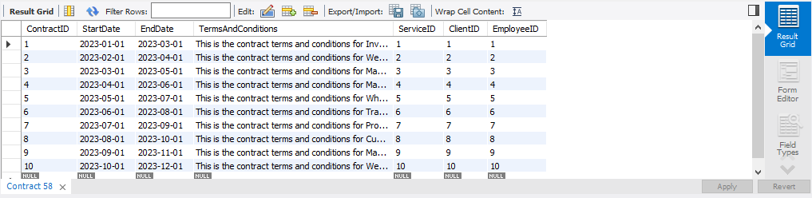

# INSERT INTO Payment (PaymentID, ContractID, Amount, PaymentDate) VALUES

|  |  |  |  |
| --- | --- | --- | --- |
| (1, | 1, | 1000, | '2023-01-01'), |
| (2, | 2, | 2000, | '2023-02-01'), |
| (3, | 3, | 3000, | '2023-03-01'), |
| (4, | 4, | 4000, | '2023-04-01'), |
| (5, | 5, | 5000, | '2023-05-01'), |
| (6, | 6, | 6000, | '2023-06-01'), |
| (7, | 7, | 7000, | '2023-07-01'), |
| (8, | 8, | 8000, | '2023-08-01'), |
| (9, | 9, | 9000, | '2023-09-01'), |
| (10, | 10, | 10000, | '2023-10-01'); |

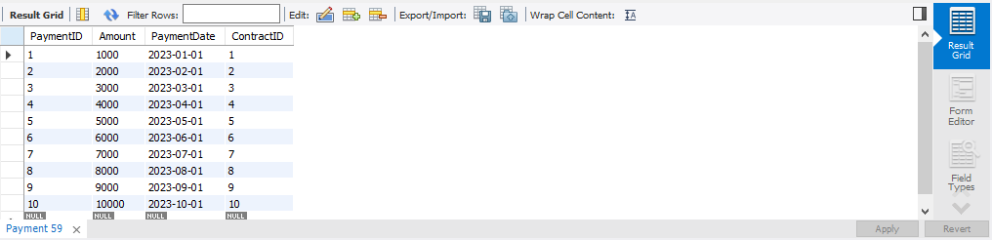

**# % Updation %**

# UPDATE Client

SET FirstName = 'James' WHERE ClientID = 1;

# UPDATE Client

SET Phone = '545-545-1216'

WHERE ClientID = 5;

# UPDATE Client

SET Address = '781 Oak Street' WHERE ClientID = 2;

# UPDATE Client

SET Phone = '555-555-1314'

WHERE ClientID = 3;

# UPDATE Client

SET FirstName = 'Jack' WHERE ClientID = 7;

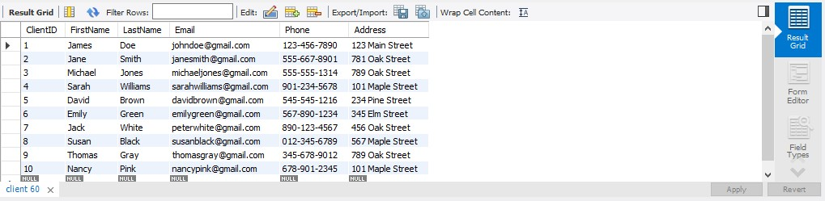

**UPDATE Employee** SET FirstName = 'John', LastName = 'Doe'

WHERE EmployeeID = 1;

# UPDATE Employee

SET Salary = 200500 WHERE EmployeeID = 2;

# UPDATE Employee

SET Address = '21 Brookfield St' WHERE EmployeeID = 8;

# UPDATE Employee

SET Salary = 100000 WHERE EmployeeID = 3;

# UPDATE Employee

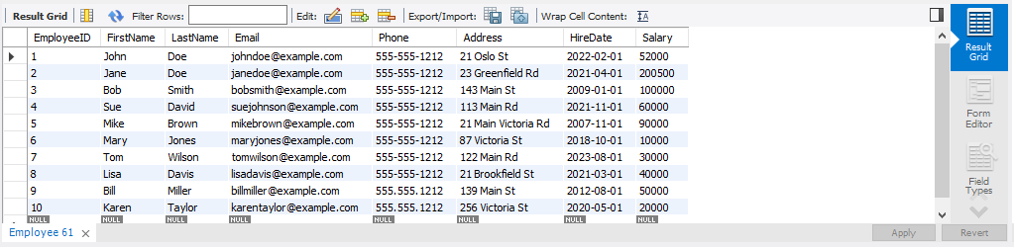SET LastName = 'David' WHERE EmployeeID = 4;

# UPDATE Project

SET Title = "Inventory Management System" WHERE ProjectID = 1;

# UPDATE Project

SET StartDate = "2010-04-01"

WHERE ProjectID = 8;

# UPDATE Project

SET Description = "Only Build a new website to promote products and services." WHERE ProjectID = 2;

# UPDATE Project

SET StartDate = "2023-06-01"

WHERE ProjectID = 3;

# UPDATE Project

SET Title = "Inventory Management System" WHERE ProjectID = 9;

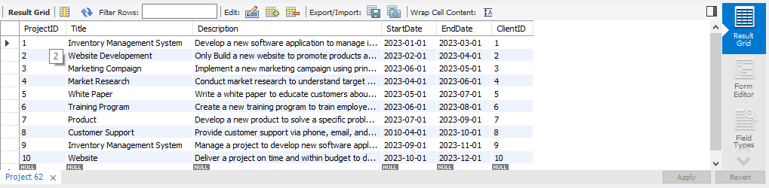

# UPDATE task

SET EndDate = "2023-12-01" WHERE TaskID = 8;

# UPDATE task

SET EndDate = "2019-02-03" WHERE TaskID = 5;

# UPDATE task

SET Description = "Developing backend." WHERE TaskID = 2;

# UPDATE task

SET EndDate = "2023-09-01" WHERE TaskID = 3;

# UPDATE task

SET Description = "Testing" WHERE TaskID = 7;

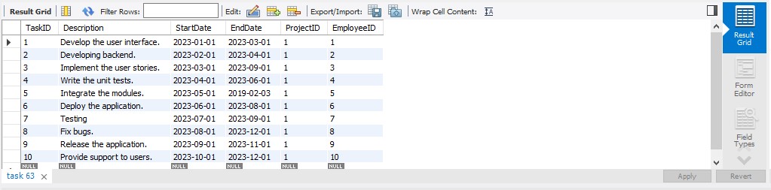

# UPDATE Service

SET Name = 'Software Developement Service' WHERE ServiceID = 1;

# UPDATE Service

SET Description = 'New Description' WHERE ServiceID = 2;

# UPDATE Service

SET Name = 'Cyber Security' WHERE ServiceID = 7;

# UPDATE Service

SET Name = 'Testing' WHERE ServiceID = 3;

# UPDATE Service

SET Name = 'Software Developement Service' WHERE ServiceID = 6;

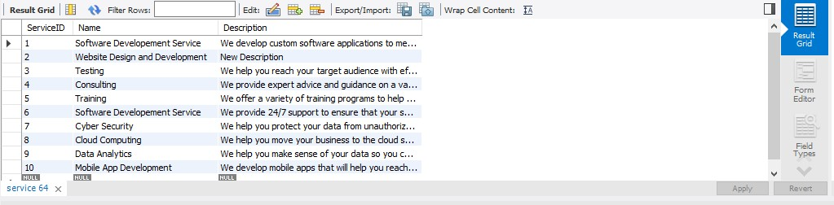

# UPDATE Contract

SET EndDate = '2023-03-01' WHERE StartDate = '2023-01-01';

# UPDATE Contract

SET TermsAndConditions = 'This is the new contract terms and conditions for Service 1.' WHERE ServiceID = 1;

**UPDATE Contract** SET EmployeeID = 2 WHERE ClientID = 2;

# UPDATE Contract

SET EndDate = '2023-03-01'

WHERE ContractID = 3;

# UPDATE Contract

SET EndDate = '2023-03-01'

WHERE ServiceID = 3;

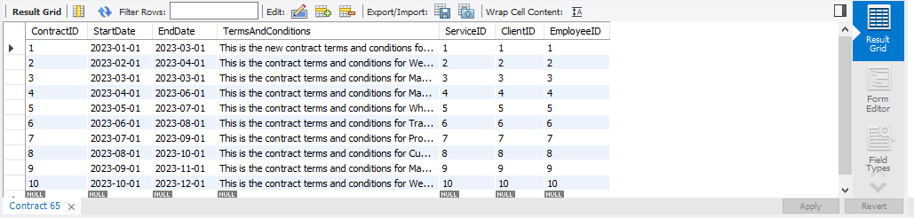

# UPDATE Payment

SET Amount = 2000 WHERE ContractID = 1;

# UPDATE Payment

SET PaymentDate = '2023-03-01' WHERE PaymentID = 5;

# UPDATE Payment

SET PaymentDate = '2023-06-01' WHERE Amount > 5000;

# UPDATE Payment

SET PaymentDate = '2022-08-01' WHERE Amount < 8000;

# UPDATE Payment

SET Amount = 22000 WHERE ContractID = 8;

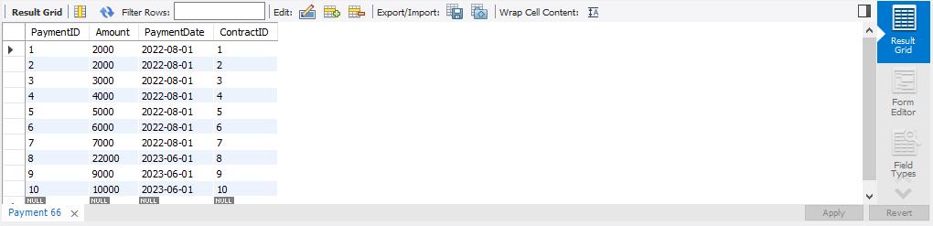

**#-----------------------------------------% SELECT %**

**SELECT** *

**FROM** Employee

WHERE HireDate > '2022-01-01';

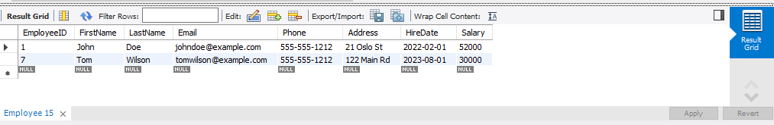

**SELECT** Title, StartDate

**FROM** Project;

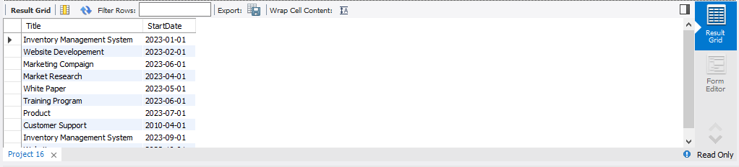

**SELECT** *

**FROM** Employee

**WHERE** Salary > 50000;

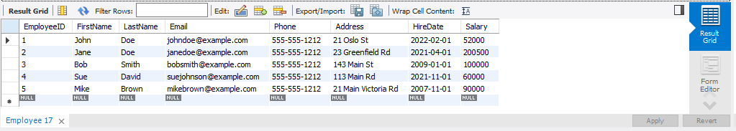

**SELECT** *

**FROM** Client

**WHERE** Email LIKE '%@gmail.com';

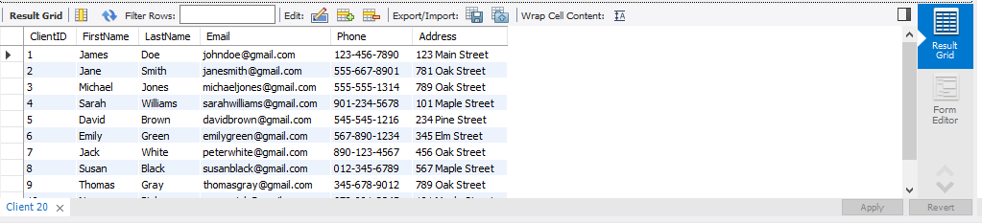

**SELECT** *

**FROM** Employee

**WHERE** Salary < 50000;

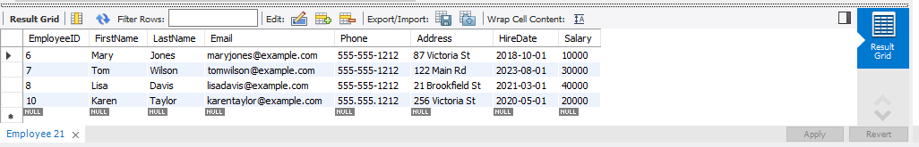

**#-----------------------------------------% JOINS %**

**SELECT**

Task.*, Project.*, Client.*, Employee.*

**FROM** Task

**JOIN** Project

**ON** Task.ProjectID = Project.ProjectID

**JOIN** Client

**ON** Project.ClientID = Client.ClientID

**JOIN** Employee

**ON** Task.EmployeeID = Employee.EmployeeID;

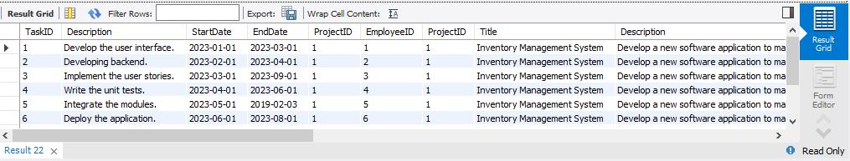

**SELECT**

Client.*, Project.*

**FROM** Client

**JOIN** Project

**ON** Client.ClientID = Project.ClientID;

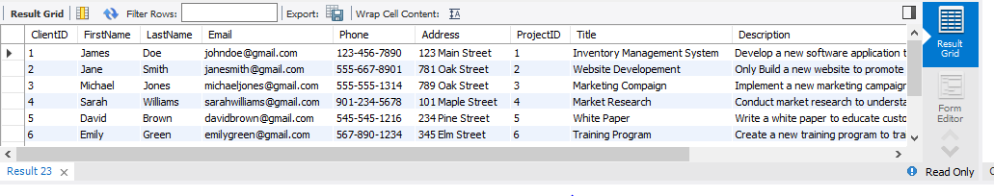

**SELECT**

Task.*, Project.*, Employee.*

**FROM** Task

**INNER JOIN** Project

**ON** Task.ProjectID = Project.ProjectID

**INNER JOIN** Employee

**ON** Task.EmployeeID = Employee.EmployeeID;

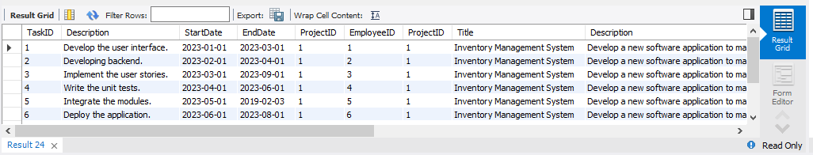

**SELECT**

Client.*, Project.*

**FROM** Client

**LEFT JOIN** Project

**ON** Client.ClientID = Project.ClientID;

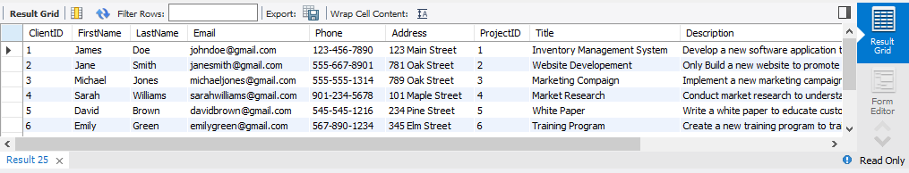

**SELECT**

Client.*, Project.*

**FROM** Client

**RIGHT JOIN** Project

**ON** Client.ClientID = Project.ClientID;

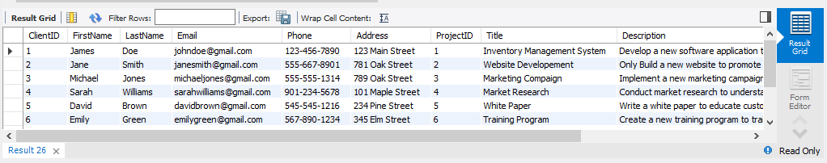

**#-----------------------------------------% CASES %**

**SELECT**

Title,

**CASE**

**WHEN** EndDate > CURDATE() **THEN** 'Active'

**ELSE** 'Completed'

**END AS** Status

**FROM** Project;

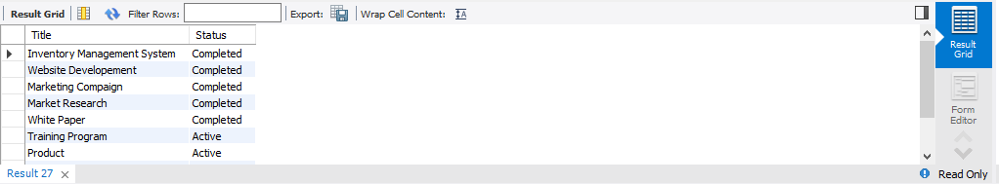

**SELECT**

CONCAT(FirstName, ' ', LastName) AS FullName,

**CASE**

**WHEN** Phone <> '' **THEN** 'Individual'

**WHEN** Email <> '' **THEN** 'Company'

**ELSE** 'Unknown'

**END AS** Category

**FROM** Client;

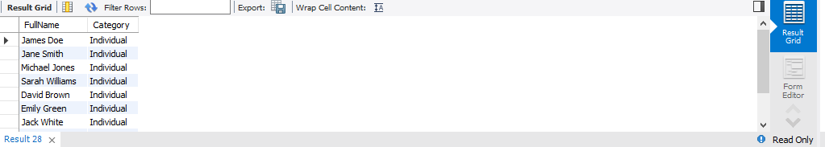

**SELECT**

Description,

**CASE**

**WHEN** DATEDIFF( EndDate, CURDATE()) <= 3 **THEN** 'Urgent'

**ELSE** 'Normal'

**END AS** Priority

**FROM** Task;

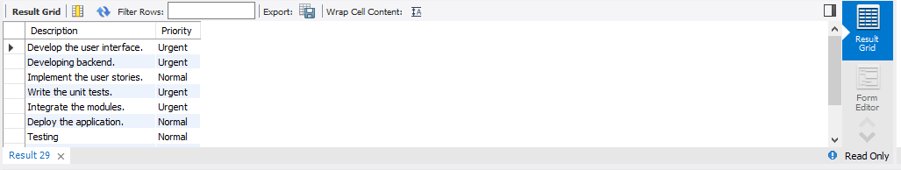

**SELECT**

CONCAT(FirstName, ' ', LastName) AS FullName,

**CASE**

**WHEN** YEAR(HireDate) < 2020 **THEN** 'Senior'

**ELSE** 'Junior'

**END AS** ExperienceLevel

**FROM** Employee;

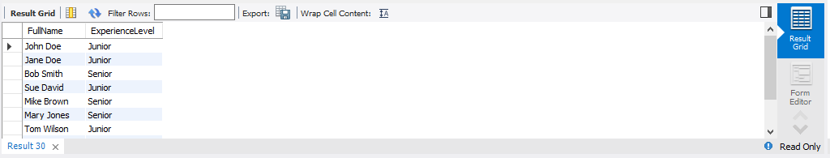

**SELECT**

Title,

**CASE**

**WHEN** (

**SELECT** COUNT(*)

**FROM** Task

**WHERE** Task.ProjectID = Project.ProjectID) > 5 **THEN** 'High'

**ELSE** 'Low'

**END AS** TaskComplexity

**FROM** Project;

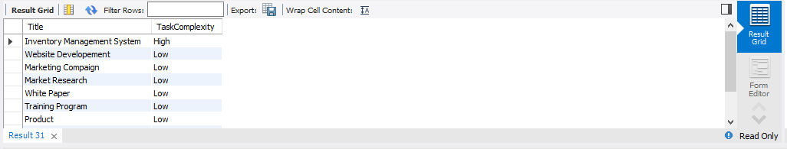

**#-----------------------------------------% VIEWS %**

**CREATE** **VIEW** ActiveContracts **AS**

**SELECT**

c.ContractID,

c.StartDate,

c.EndDate,

cl.FirstName **AS** ClientFirstName,

cl.LastName **AS** ClientLastName,

e.FirstName **AS** EmployeeFirstName,

e.LastName **AS** EmployeeLastName

**FROM** Contract c

**JOIN** Client cl

**ON** c.ClientID = cl.ClientID

**JOIN** Employee e

**ON** c.EmployeeID = e.EmployeeID

**WHERE** c.EndDate > CURDATE();

**SELECT** * FROM ActiveContracts;

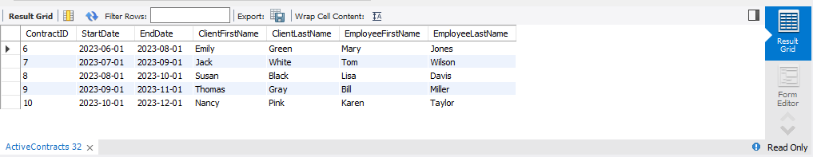

**CREATE VIEW** ProjectDetails **AS**

**SELECT**

ProjectID, Title, StartDate, EndDate

**FROM** Project;

**SELECT** * **FROM** ProjectDetails;

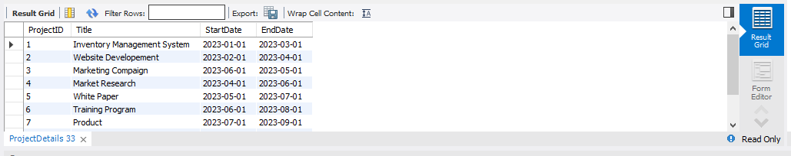

**CREATE VIEW** EmployeeTasks **AS**

**SELECT** e.EmployeeID, e.FirstName, e.LastName, e.Email, e.Phone, e.Address,t.TaskID,t.Description, t.StartDate, t.EndDate

**FROM** Employee **AS** e

**JOIN** Task **AS** t

**ON** e.EmployeeID = t.EmployeeID;

**SELECT** * **FROM** EmployeeTasks;

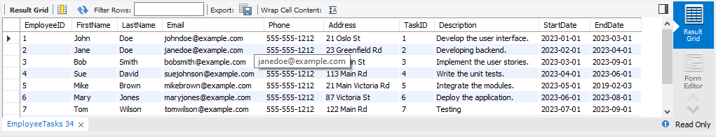

**CREATE VIEW** PaymentDetails **AS**

**SELECT**

PaymentID, Amount, PaymentDate

**FROM** Payment;

**SELECT** * **FROM** PaymentDetails;

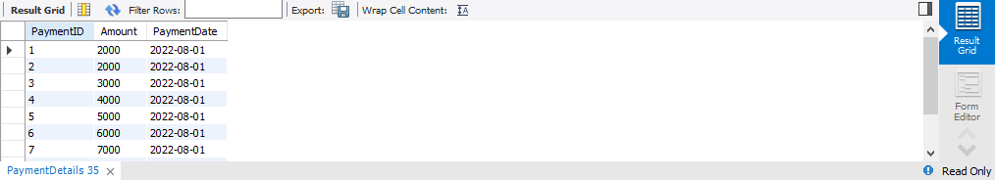

**CREATE VIEW** ContractTerms **AS**

**SELECT** ContractID, StartDate, EndDate, TermsAndConditions

**FROM** Contract;

**SELECT** * **FROM** ContractTerms;

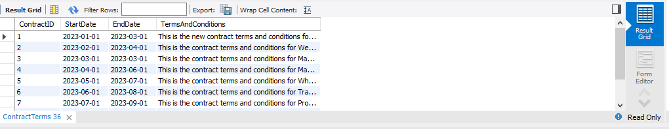

**#-----------------------------------------% PROCEDURES %**

DELIMITER //

**CREATE PROCEDURE InsertClient (**

IN clientID INT,

IN firstName VARCHAR(255),

IN lastName VARCHAR(255),

IN email VARCHAR(255),

IN phone VARCHAR(255),

IN address VARCHAR(255)

)

**BEGIN**

**INSERT INTO Client** (ClientID, FirstName, LastName, Email, Phone, Address)

VALUES (clientID, firstName, lastName, email, phone, address);

**END //**

DELIMITER ;

**CALL InsertClient(12, 'John', 'Doe', 'johndoe@example.com', '1234567890', '123 Main St');**

SELECT * FROM CLIENT;

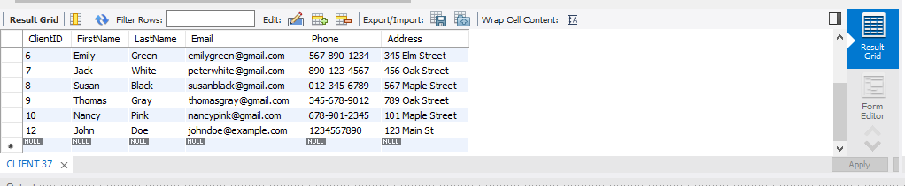

DELIMITER //

**CREATE PROCEDURE GetEmployeeTasks (**

IN employeeID INT

)

BEGIN

**SELECT** TaskID, Description, StartDate, EndDate

**FROM** Task

**WHERE** EmployeeID = employeeID;

**END //**

DELIMITER ;

**CALL GetEmployeeTasks(123);**

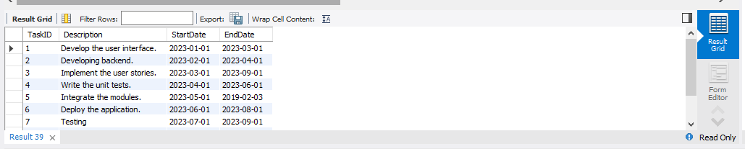

DELIMITER //

**CREATE PROCEDURE GetTaskByID (**

IN taskID INT

)

**BEGIN**

**SELECT** *

**FROM** Task

**WHERE** TaskID = taskID;

**END //**

DELIMITER ;

**CALL GetTaskByID(1);**

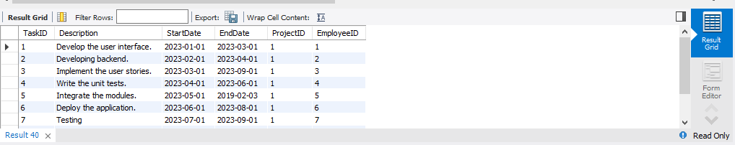

DELIMITER //

**CREATE PROCEDURE InsertProject (**

IN projectID INT,

IN title VARCHAR(255),

IN description VARCHAR(255),

IN startDate DATE,

IN endDate DATE

)

**BEGIN**

**INSERT INTO Project** (ProjectID, Title, Description, StartDate, EndDate)

VALUES (projectID, title, description, startDate, endDate);

**END //**

DELIMITER ;

**CALL InsertProject(16, 'New Project', 'This is a new project', '2023-01-01', '2023-12-31');**

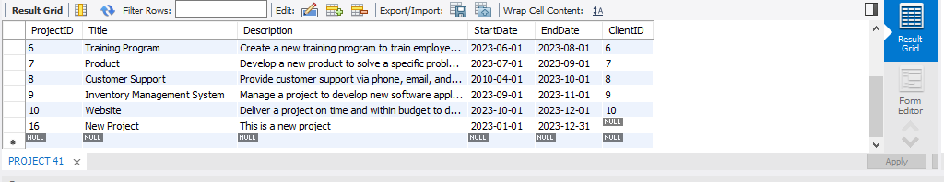

DELIMITER //

**CREATE PROCEDURE InsertService (**

IN name VARCHAR(255),

IN description VARCHAR(255)

)

**BEGIN**

**INSERT INTO** Service (Name, Description)

VALUES (name, description);

**END //**

DELIMITER ;

**CALL InsertService('Web Development', 'Creating and maintaining websites');**

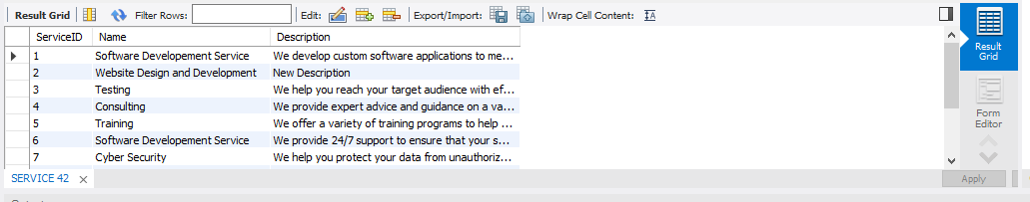

**#-----------------------------% AGGREGATE FUNCTIONS %**

**SELECT**

SUM(Amount) **AS** TotalRevenue

**FROM** Payment ;

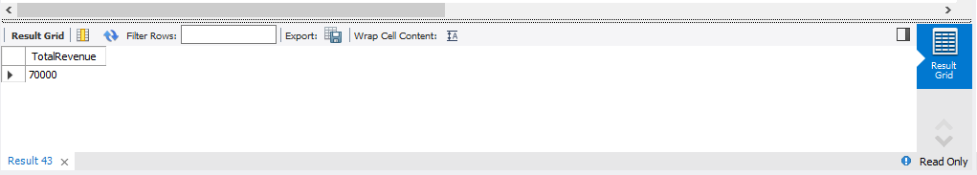

**SELECT**

AVG(DATEDIFF(EndDate, StartDate))

**AS** AverageTaskDuration

**FROM** Task;

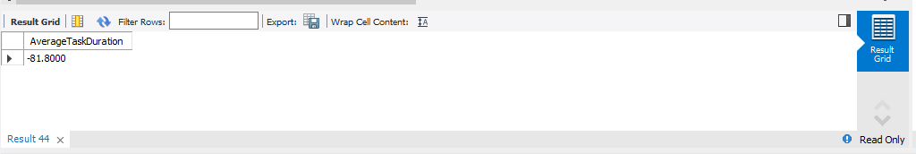

**SELECT**

MIN(StartDate) **AS** MinProjectStartDate

**FROM** Project;

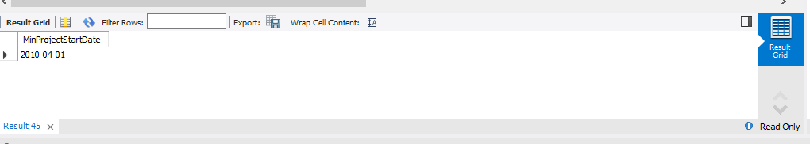

**SELECT**

COUNT(*) **AS** ActiveContracts

**FROM** Contract

**WHERE** EndDate > CURDATE();

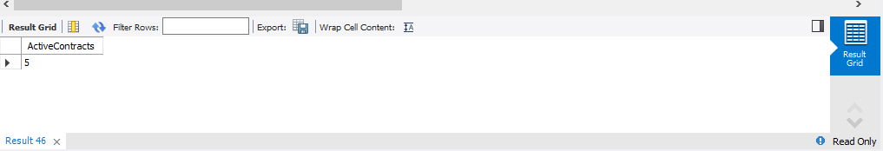

**SELECT**

YEAR(StartDate) **AS** Year,

COUNT(*) **AS** TotalProjects

**FROM** Project

**GROUP BY** YEAR(StartDate);

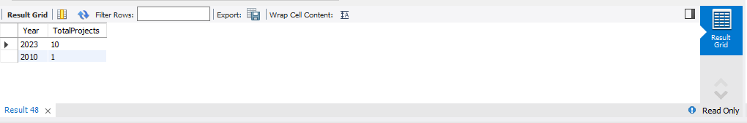

**#-----------------------------% SUB QUERIES %**

**SELECT** ClientID, FirstName, LastName

**FROM** Client

**WHERE** ClientID **IN (**

**SELECT** **DISTINCT** ClientID

**FROM** Project

**);**

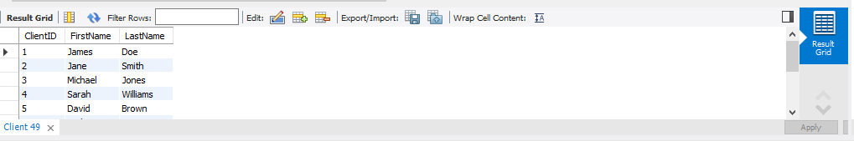

**SELECT** p.ProjectID, p.Title, **(**

**SELECT**

AVG(e.Salary)

**FROM** Employee **AS** e

**WHERE** e.EmployeeID = t.EmployeeID

**) AS** AverageSalary

**FROM** Project **AS** p

**INNER JOIN** Task **AS** t

**ON** p.ProjectID = t.ProjectID;

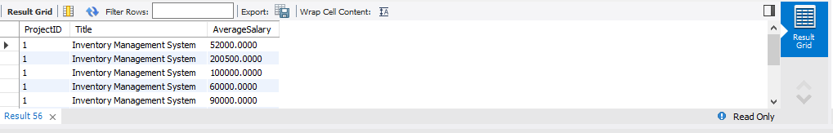

**SELECT** s.ServiceID, s.Name, s.Description

**FROM** Service **AS** s

**WHERE NOT EXISTS (**

**SELECT * FROM** Contract **AS** c

**WHERE** c.ServiceID = s.ServiceID

**);**

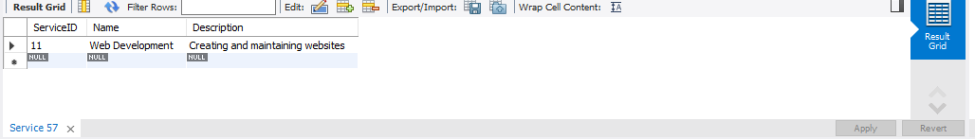

**SELECT** c.ContractID, c.StartDate, c.EndDate, **(**

**SELECT** SUM(p.Amount)

**FROM** Payment **AS** p

**WHERE** p.ContractID = c.ContractID

) **AS** TotalAmountPaid

**FROM** Contract **AS** c;

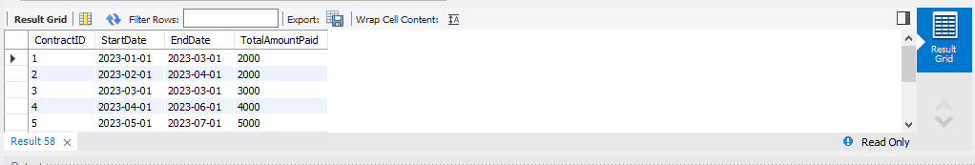

**SELECT** e.FirstName, e.LastName

**FROM** Employee AS e

**WHERE (**

**SELECT** COUNT(DISTINCT t.ProjectID)

**FROM** Task **AS** t

**WHERE** t.EmployeeID = e.EmployeeID

**) > 1;**

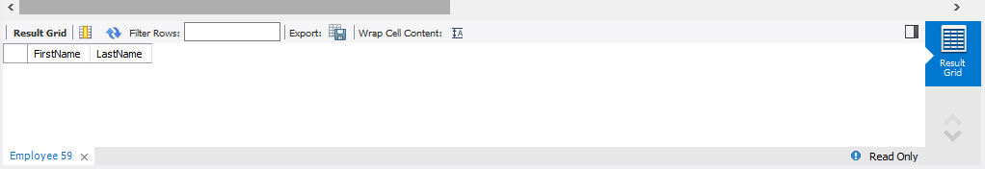

**SELECT** *

**FROM** Project

**WHERE** ProjectID **IN (**

**SELECT** ContractID

**FROM** Payment

**WHERE** Amount > 5000

**);**

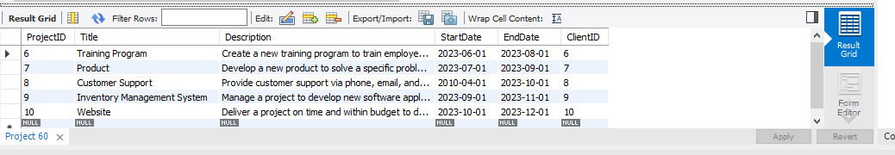



[https://github.com/taahahussainkhan/Structured-Query-Language/tree/mai](https://github.com/topics/structured-query-language) [n/Software-House-Schema](https://github.com/topics/structured-query-language)